Economic Growth in Developed and Developing Countries
Economic growth remains a central focus of development policy. Understanding its drivers, especially the heterogeneity between developed and developing countries, is crucial. This study applies machine learning techniques to quantify and compare key growth determinants across country groups. We utilized a panel dataset from the World Bank, consisting of macroeconomic indicators such as GDP per capita, investment rate, education attainment, and inflation. These were supplemented with HDI data to classify countries into two groups: developed and developing, via k-means clustering.
Random Forest regression models were trained separately for each group to predict GDP growth. Feature importances were extracted and interpreted to assess the relative influence of each variable. Additionally, convergence was tested by examining the relationship between initial GDP per capita and subsequent growth. As shown in Figure 1, developed countries exhibit a more balanced influence of investment, education, and life expectancy. In contrast, developing countries place higher weight on investment and education. It highlights how, in less advanced economies, growth still hinges heavily on the basics: building capital and educating the population.

Figure 1: Feature Importances in Developed vs Developing Countries
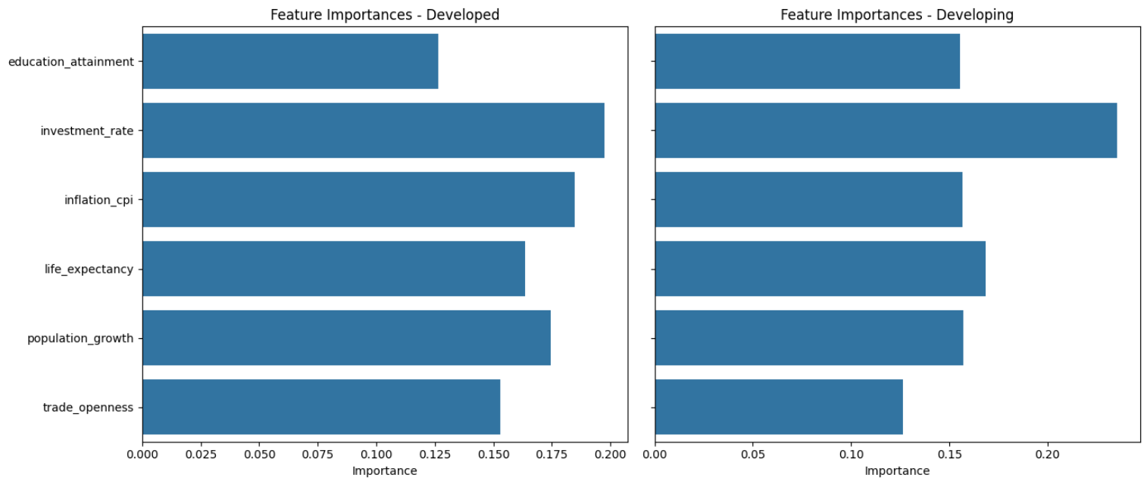

To better understand the heterogeneity in economic development across countries, I selected three clusters to reflect low, medium, and high levels of development. The resulting clusters had distinct centers—approximately 0.49 for low HDI, 0.68 for medium HDI, and 0.84 for high HDI, indicating clear separation in development stages.
Countries in the low HDI cluster tend to be the least developed, often grappling with challenges such as inadequate education and weak infrastructure. Economic growth within this group is highly volatile; while some countries experience growth from a low base, others stagnate due to political or external constraints. In modeling, investment and inflation were by far the most important features, with educational attainment far behind, perhaps due to the low quality of education typically received in these countries.
The medium HDI cluster includes many emerging economies transitioning economies. These countries tend to exhibit more stable growth rates than the low HDI group, benefiting from improving institutions, urbanization, and expanding middle classes. For this cluster, economic growth was still influenced by investment and inflation, but educational attainment played a larger role.
The high HDI cluster encompasses developed nations with larger economies, strong institutions, and high standards of living. GDP growth in this group is generally more stable, driven by innovation, capital efficiency, and advanced human capital rather than physical investment alone. In modeling, inflation and investment were still very important, but an otherwise unimportant variable trade openness became the most important feature in the High model, which emphasizes the importance of international trade for large economies but is much less significant for smaller HDI countries. As illustrated in Figure 2, the relative importance of predictors shifts as countries develop, reflecting structural differences across HDI tiers.
Figure 2: Feature Importances in Low vs Medium vs High HDI Countries
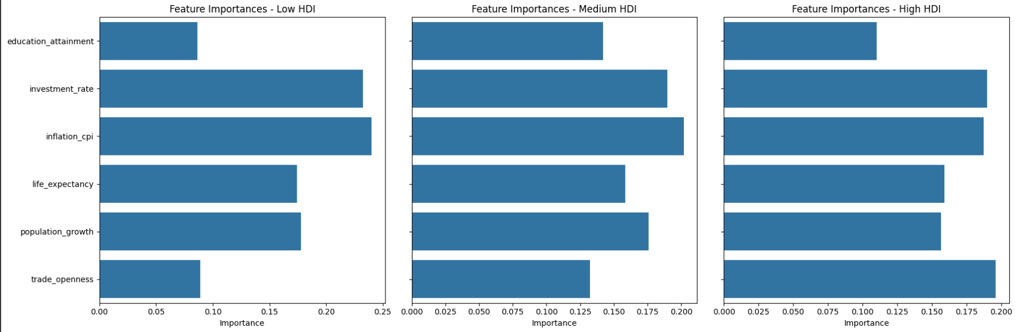
Figure 3 illustrates a slight negative relationship between initial GDP per capita and GDP growth. The downward-sloping trend on a log scale confirms economic convergence, in line with neoclassical growth theory. Lower-income countries exhibit faster growth rates, reflecting higher marginal returns to capital and policy reform potential.

Figure 3: Economic Convergence - Initial GDP vs GDP Growth
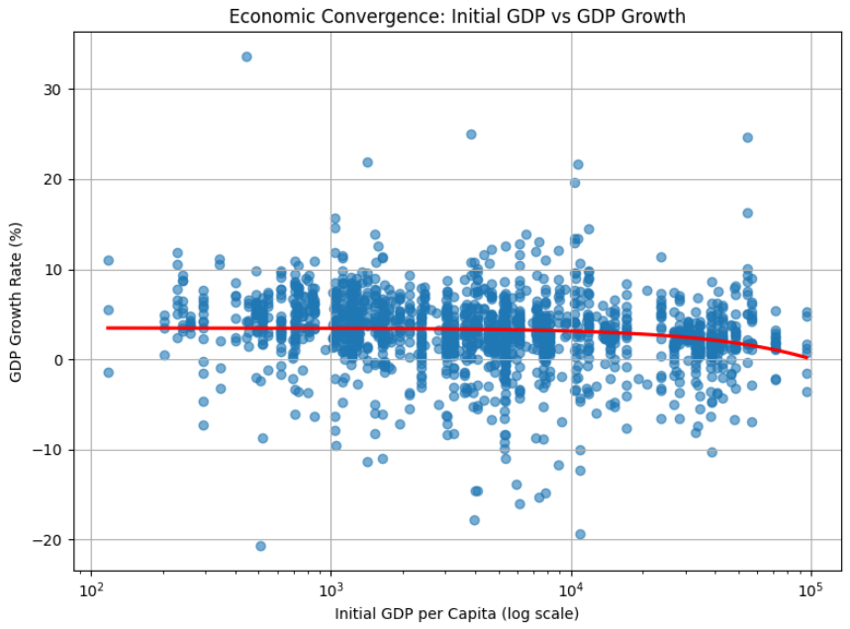

The Random Forest models predict that developed countries will, on average, grow approximately 1.09 percentage points faster than developing countries. This result may seem counterintuitive given classical convergence theory. However, several hypotheses may explain it. Developed countries may exhibit more stable macroeconomic environments, stronger institutions, and more efficient use of capital, enabling consistent but moderate growth. In contrast, developing countries may face structural constraints, political instability, or data volatility that reduce their observed or predicted growth rates, despite theoretical convergence potential.
These findings reinforce the notion that while all countries benefit from capital and human development, the stage of economic development determines the relative payoff. In all models, investment and inflation measures were of the utmost importance, and policymakers of all countries should ensure appropriate levels to ensure growth. Other influential variables as shown can depend on the stage of development that an economy is experiencing, as measured by the HDI.

